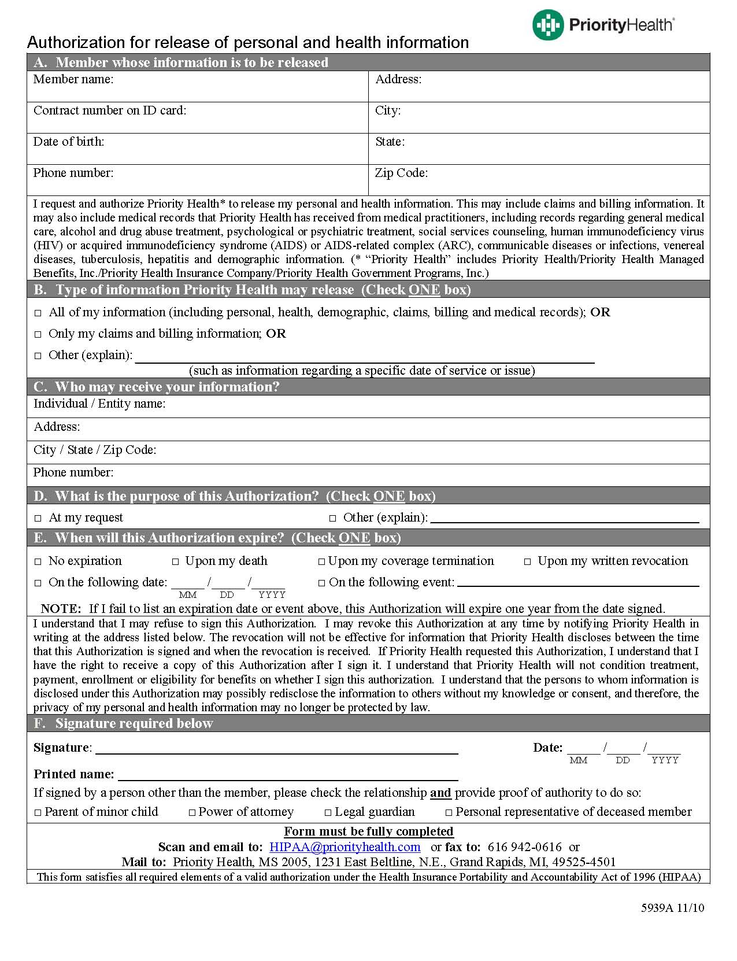
Order No. 01-21845 - 020
Preston Mayberry
07/28/2007
FROM 07/28/2007 TO PRESENT: ANY and ALL records, including but not limited to any and all documentation or other records generated by any outside source pertaining to Preston Mayberry SSN: XXX-XX-2973, DOB: 07/28/2007.
2869 Jolly Rd
Okemos, MI 48864
Axiom Requisition Copy Service as agent of Amanda M.Trott
X
At the conclusion of litigation
X
(877) 886-5090
812 WATSON
GRAND RAPIDS
MI
49504
X
Litigation

